Chapter 10, Problem 88.

Use PSpice to find v_{o} and i_{o} in the circuit of Fig. 10.130.
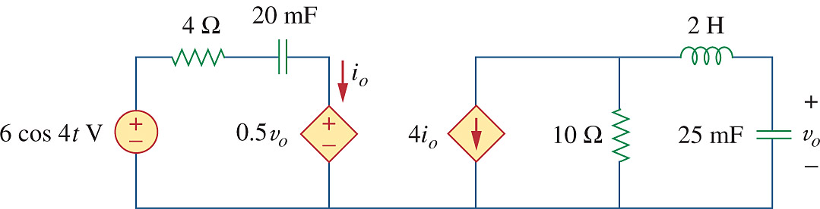

Figure 10.130
For Prob. 10.88.

